3rd International Symposium for Plant Vascular Pathosystems (ISPVP)
Organization committee meeting (3/27/26, 1 pm CST)
1. Introduction: Committee Members
- Chair: Kranthi Mandadi, Texas A&M University
- Co-Chair: Nian Wang, Univ. of Florida
- Chi-Kuan Tu, Texas A&M University
- Baoye He, Texas A&M University
- Veronica Ancona: Texas A&M-Kingsville
- Ute Albrecht, University of Florida
- Amit Levy, University of Florida
- Kirsten Pelinsky, University of Florida
- Jinyun Li, University of Florida
- Caroline Roper, University of California-Riverside
- Laure Beven, INRAE, France

Scientific Advisory Committee
- Saskia A. Hogenhout, John Innes Centre, Norwich, UK
- Leonardo de la Fuente, Auburn University, USA
- Xiaoling Deng, South China Agricultural University, China
- Zhanjun Lu, Gannan Normal University, China
- Wenbo Ma, The Sainsbury Laboratory, UK
- Marcos Antonio Machado, Centro de Citricultura Sylvio Moreira, Instituto Agronoˆmico, Brazil
- Xuefeng Wang, South West University, China

2. Dates & Location: October 20-23th, 2026
Holiday Inn Resort (Beach Front), 100 Padre Blvd., South Padre Island, TX 78597
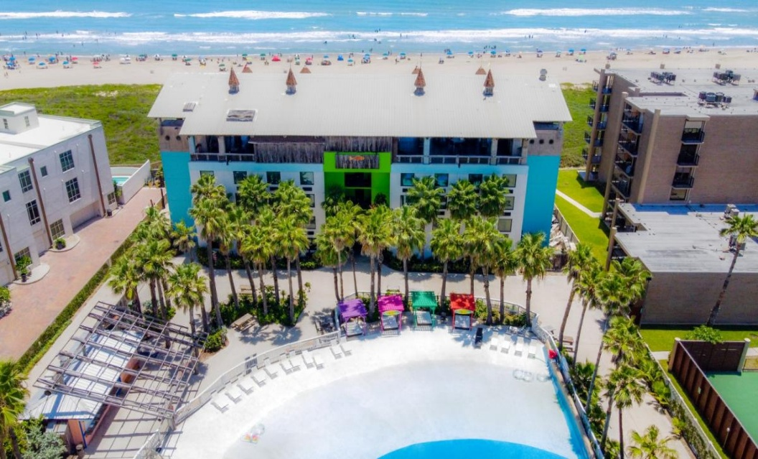
Negotiated Room Rate: $89 (with room block)

3. Tentative schedule:
- Arrival and registration on October 20, 2026 (Tuesday)
- October 21, 2026 (Wednesday), meeting day 1
- October 22, 2026 (Thursday), meeting day 2
- October 23, 2026 (Friday), meeting day 3

Registration and Abstract Submission:
- May 1, 2026 - August 1, 2026: Early Bird Registration and Abstract Submission
- August 2, 2026 - August 23, 2026: General Registration and Abstract Submission
- August 24, 2026 - September 25, 2026: Late Registration and Poster Abstract Submission Only

4. The theme of the conference: Confronting Endemic and Emerging Plant Vascular Pathogens, Insect vectors, and Diseases Together.

The conference will focus on diagnostics, epidemiology, omics, Intelligent (AI) technologies, pathogen-plant-insect interactions, pathogen biology, insect biology, plant biology, biotechnology, and disease management/socio-economics.

5. SCIENTIFIC PROGRAM
The conference will comprise approximately seven two-hour general sessions/talks, plus 2 late-afternoon/evening poster sessions (Wednesday and Thursday). For each session, there could be 1-2 invited speaker presentations and 3-4 selected oral presentations.

6. Discussion of sessions
- Session: Diagnostics, epidemiology, surveillance for disease, and insect vector control
- Session: Emerging Technologies, Omics and AI-powered Tools
- Session: Pathogen Biology and Microbiome
- Session: Insect Biology and Insect-Pathogen Interactions
- Session: Plant Biology and Plant Pathogen Interactions
- Session: Genetics, breeding, CRISPR, biotechnology for disease and insect vector control
- Session: Integrated Disease/Pest Management, including Economic Analyses

7. Length of talks
30 min (Invited)/15min (Selected)

8. Registration and Abstract Submission (proposed, needs discussion)
- May 1, 2026 - August 1, 2026: Early Bird Registration and Abstract Submission
- August 2, 2026 - August 23, 2026: General Registration and Abstract Submission
- August 24, 2026 - September 25, 2026: Late Registration and Poster Abstract Submission Only
Submission format: Email submissions to XXX

9. Registration fee ($)

 | Regular (Assistant, Associate, Professor, and equivalent scientists) | Research staff (Postdocs, technicians, and equivalent staff) | Students
Early Bird Registration and Abstract Submission (May 1, 2026 - August 1, 2026) | 450 | 350 | 250
General Registration and Abstract Submission (August 2, 2026 - August 23, 2026) | 500 | 400 | 300
Late Registration and Poster Abstract Submission Only (August 24, 2026 - September 25, 2026) | 550 | 450 | 350

10. Food, coffee breaks, receptions, and banquets
- Breakfast: included.
- Lunch: included.
- Dinner: not included except closing dinner.
- Opening Reception (finger food, 1 soft/alcohol drink ticket) on 10/21/26 (Wednesday evening could be concurrent with the poster session)
- Closing Banquet/Dinner (1 soft/alcohol drink ticket) on 10/22/26 (Thursday evening)
- Coffee breaks: 2 coffee breaks/day

11. Fundraising
- Seek funding support with our respective centers/departments or industry sponsors.
- Sponsor letter template (coming up).

12. Travel support
- 3-4 Student travel award (1 pg. research statement, 1 letter of support)
- $500/person

13. Research excellence awards
- Students (3) and research staff (3).
- $100-300/person and a certificate

14. Speakers
- Each committee member may recommend up to 10 speakers based on their scientific contributions over the last 3 years.
- We will meet again and vote to select 2-3 external invited speakers (30-minute talks)
  - We can offer travel support to those invited speakers.
- The organizing committee members who will submit an abstract can also be selected as an invited speaker to speak for one of the available slots: 30 minutes or 15 minutes

